Covid-19 from the Perspective of Preschool Prospective Teachers: What Can We Do for Children

Derya ATABEY
Alanya Alaaddin Keykubat University, Turkey, deryaatabey1982@gmail.com

Abstract: The current study was carried out to determine the problems that preschool children experience during Covid-19 and also what could be done from perspectives of preschool prospective teachers. The working group of the study was made up of 45 projects prepared by 15 preschool prospective teachers attending to the midterm exam of lecture of “Practices of social service” in Alanya Alaaddin Keykubat University, Faculty of Education, Department of Preschool Education. As a data collection tool, the project preparation form (A unstructured survey form) that was prepared by the researcher was used. The study was carried out qualitative research methods and the projects comprising the working group of the study were analyzed with content analysis technique. At the end of the study, the problems that preschool children might experience in the pandemic period, the purposes to decrease these problems to minimum, the concepts and values to be attained and recommendations for projects were determined. Various recommendations were made in line with the findings obtained.

Key words: Covid-19, Pandemic, Preschool children, Preschool prospective teacher, Project
Introduction
Starting in the city of Wuhan in the state of Hubei in China, influencing the whole world in a short time, the disease of Covid-19 was declared as a pandemic. This case has affected all humanity and its impacts were unfortunately felt in many fields such as health, education, economy, social-private-daily life and tourism (Banna et al., 2020; Blankenberger & Williams, 2020; Blundell et al., 2020; Cosic et al., 2020; Lesser & Nienhuis, 2020; Odriozola-González et al., 2020; Onyema et al., 2020; Patrick et al., 2020; Power, 2020; Tecirli et al., 2020; Tull et al., 2020; Tümen Akyıldız, 2020; Unger & Meiran, 2020; Wong & Moorhouse, 2020; Zhang & Ma, 2020).
In this process, children have seen the negative sides of this process by means of both their close circles and communication technologies. A great many things like the news of death and disease, closing of the schools, curfews, closing of such special places as parks-playgrounds-theatres for children, experiencing changes like mask and gloves even in clothes and accessory habits, the fact that parents do not go to work and siblings do not go to school, not visiting relatives, avoiding such contacts as hugging and kissing, washing the grocery bought have surely affected children as well as adults.
According to Piaget, preschool children who cannot attain abstract thinking skill yet in the preoperational stage regard themselves in the center of the world and have a perspective peculiar to them. They do the reasoning from specific to specific and they develop cliché judgments because of their limited experiences. They simply reason and are curious; they ask to many questions and want to know the answers of all the questions. They are weak in making a cause and effect relation and it is hard to perceive in this period (Atıcı, 2018; Gander & Gardiner, 2001; Köksal Akyol, 2002). They cannot fully comprehend the concept of death (Bildik, 2013; Schonfeld, 1993; Sezer & Sayar, 2009). The concept of disease in children varies in terms of their ages, development stages, self-consciousness and family ties (Schmidt & Lehmkuhl, 1994). In a study carried out over 83 children in the age groups of 4-5, 7-8, 9-10 and 11-12 to determine how they define disease and health by Myant and Williams (2005), it was found that the definitions of health and disease polarize more depending on age.
When it comes to the developmental features of preschool period children in this period, it is rather difficult for them to understand such an abstract concept as virus. The pandemic period which is hard to be perceived even by adults could undoubtedly lead to the fact that children have some fears and anxiety and exhibit various emotional disorders and behavioural problems. They could experience the fear for losing their parents or a relative. They could blame themselves for the lost parents or a member in the family. They could develop the phobia of leaving home. It is likely to see some problems in their nutrition and sleeping habits. It is likely to see some developmental disorders with physical development in the first place depending on inactiveness. After a long time when the pandemic is over, they could experience such problems as separating from parents, socialization and adaptation etc. Even though this effect varies depending on the socio-cultural and socio-economic condition where children are in, effects of these negative experiences in childhood could emerge in the coming periods (Boyraz & Legros, 2020; Çaykuş & Mutlu Çaykuş, 2020; Dalton et al., 2020; Demir Öztürk et al., 2020; Dubey et al., 2020; Ghosh et al., 2020; Guan et al., 2020; Jiao et al., 2020; United Nations, 2020; Yoshikawa et al., 2020).
The support taken during the negative experiences in the childhood period are of great importance. Both all the institutions and organizations and the community must fulfil the tasks and responsibilities they have in order that children could get rid of this and such kind of condition with a minimum harm, feel self-confidents and trust the community where they carry on their existence as an individual, feel the sense of belonging, attain social values and internalize them and become a useful individual for the community when they are an adult individual in the years ahead. Making project recommendations regarding what to do in this sense, combining, enlarging and turning them into systematic programs and putting them into action in the crisis period are of vital importance.
Due to all these reasons, the current study was carried out to determine the problems that preschool children experience during Covid-19 and also what could be done from perspectives of preschool prospective teachers who are good observers. In this purpose, the following questions were tried to be answered:

- What kind of problems do preschool period children experience in the pandemic period?
- What should we aim in order to minimize the problems that preschool period children experience in the pandemic period?
- Which concepts could be used in this period?
- Which values could be used in this period?
- What kind of activities could be conducted in this period?
Method
The Model of the Study
In this research, qualitative research approach was used to obtain data thoroughly, to learn participants' individual perceptions directly and to understand the present situation. The projects comprising the working group were analyzed with content analysis technique. (Baltacı, 2019; Yıldırım, 1999). Content analysis is the determination of the existence, meanings and relations of certain words or concepts in the text or texts comprising the sampling, analysis of them and making of deductions with regard to the message in the texts (as cited in Büyüköztürk et al., 2008; Stemler, 2000).
Working Group
The working group of the study was made up of the projects prepared by 15 preschool prospective teachers attending the midterm exam of lecture of “Practices of social service” in Alanya Alaaddin Keykubat University, Faculty of Education, Department of Preschool Education. Each prospective teacher prepared 3 projects and 45 projects comprised the working group of the research.
Data Collection Tool
The data was obtained by means of the unstructured survey form and personal information form, prepared by the researcher. In the personal information form, gender and age of the prospective teachers were given. "The unstructured project preparation survey form" was used to determine the opinions and recommendations of the preschool prospective teachers.

Design a social project as a prospective teacher based on pandemic period and preschool children
The problems that preschool children experience during Covid-19:
The purposes to decrease problems to minimum:
The concepts to be attained in the pandemic period:
The values to be attained in the pandemic period:
Recommendations likely to be made in the pandemic period:

Statistical Analysis of the Data
The projects prepared to make the statistical analysis of the data were coded with numbers. The demographic information of the prospective teachers participating in the research were shown in numbers and percentages. The frequency and percentage distributions of the data obtained with “Project Preparation Form” were calculated and given as graphics.
Findings
In this part, the findings concerning the statistical analyses realized in line with the aims of the research are given
Table 1. The distribution of the prospective teachers participating in the research in terms of gender
Gender | N | %
Woman | 6 | 40
Man | 9 | 60
Total | 15 | 100

As is given in Table 1, 60% of the prospective teachers participating in the research were man and 40% were woman.
Table 2. The distribution of the prospective teachers participating in the research in terms of ages
Age | N | %
21 | 8 | 53.33
20 | 2 | 13.33
22 | 2 | 13.33
23 | 2 | 13.33
28 | 1 | 6.67
Total | 15 | 100
As is given in Table 2, 53.33% of the prospective teachers participating in the research were 21, 13.33% were 20, 13.33% were 22, 13.33% were 23 and 6.67% were 28 years of age.
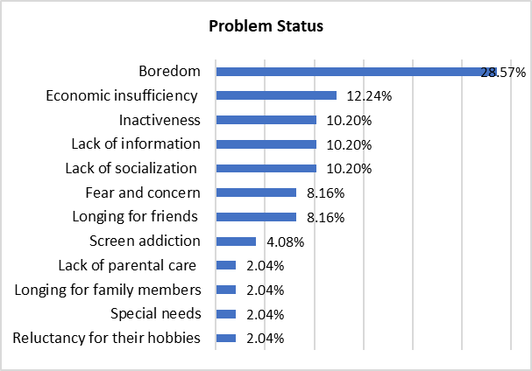

Figure 1. The problems that preschool children experience during Covid-19
As is shown in Figure 1, preschool prospective teachers pointed out the problems children experienced in the pandemic period as boredom (28.57%), economic insufficiency (12.24%), inactiveness (10.20%), lack of information (10.20%), lack of socialization (10.20%), fear and concern (8.16%), longing for friends (8.16%), screen addiction (4.08%), lack of parental care (2.04%), longing for family members (2.04%), special needs (2.04%) and reluctancy for their hobbies (2.04%).

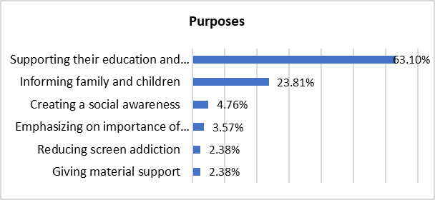

Figure 2. The purposes to decrease problems to minimum
As given in Figure 2, preschool prospective teachers pointed out that the studies to be carried out for the solution of the problems experienced in the pandemic period should be realized for the purpose of supporting their education and developments (63.10%), informing family and children (23.81%), creating a social awareness (4.76%), emphasizing on importance of health workers (3.57%), reducing screen addiction (2.38%), giving material support (2.38%).

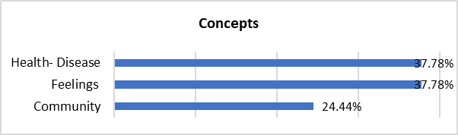

Figure 3. The concepts to be attained in the pandemic period
As is shown in Figure 3, preschool prospective teachers stated the concepts to be attained in the pandemic period as “Concepts regarding health- disease” (37.78%), “Concepts regarding feelings” (37.78%), “Concepts regarding community” (24.44%).
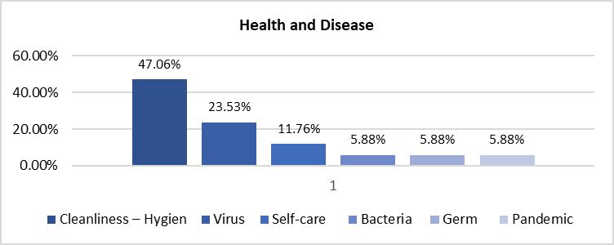

Figure 4. Concepts regarding health and disease
As is given in Figure 4, the concepts of cleanliness – hygiene (47.06%), virus (23.53%), self-care (11.76%), bacteria (5.88%), germ (5.88%), pandemic (5.88%) were taken place.

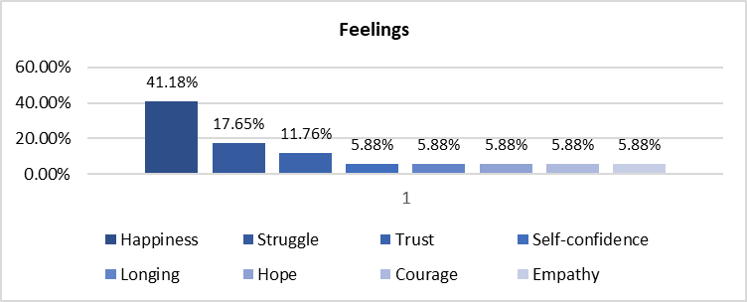

Figure 5. Concepts regarding feelings
As is given in Figure 5, the concepts of happiness (41.18%), struggle (17.65%), trust (11.76%), self-confidence (5.88%), longing (5.88%), hope (5.88%), courage (5.88%), empathy (5.88%) were taken place.

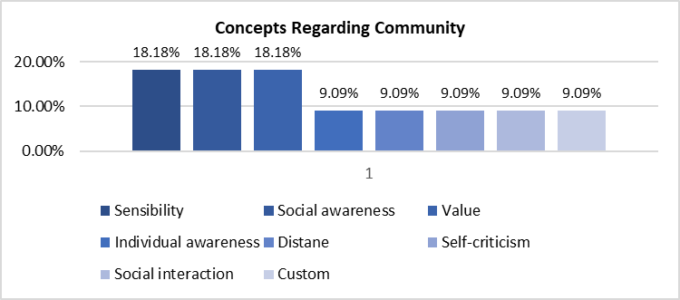

Figure 6. Concepts regarding community
As is given in Figure 6, the concepts of sensibility (%18.18), social awareness (%18.18), value (%18.88), ındividual awareness (%9.09), distance (%9.09), self-criticism (%9.09), social interaction (%9.09), custom (%9.09) were taken place.
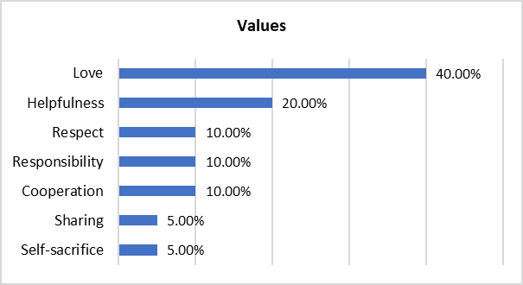

Figure 7. The values to be attained in the pandemic period
As is shown in Figure 7, preschool prospective teachers stated the values to be attained in the pandemic period as “Love” (40%), “Helpfulness” (20%), “Respect” (10%), “Responsibility” (10%), “Cooperation” (10%), “Sharing” (5%), “Self-sacrifice” (5%).

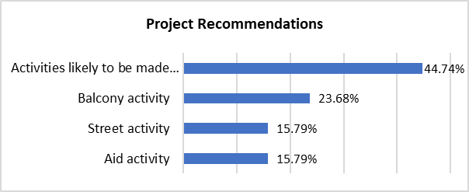

Figure 8. Recommendations likely to be made in the pandemic period

As given in Figure 8, preschool prospective teachers stated the recommendations likely to be made in the pandemic period as “Activities likely to be made through communication tools” (44.74%), “Balcony activity” (23.68%), “Aid activity” (15.79%), “Street activity” (15.79%).
In the projects likely to be made through communication tools, the recommended activities are making of informative programs, reading stories to children regularly, preparing books at home to donate for a library in the leadership of an educator, placing entertaining public service ads about hygiene between cartoons, decorating the windows and balconies of the houses by all the children in the guidance of teachers by means of various artistic activities, telling what is done by children to each other through visual connections, combining the videos taken by families regarding hygiene, mask, distance by teachers and sending back them to the families, organizing simple entertaining competitions, providing the communication of children with the elderly people in the old people’s home together with the educators and families through visual connections, making a game mates between preschool prospective teachers and children through visual connection, preparing surprise gifts with children who cannot see their parents in accompany with the educator and make it delivered, writing a thankful letter and making various artistic activities for health workers and giving it as a gift.
In the projects to be made within the content of balcony-garden, it is recommended to handing out balloons in various colours and features to children by municipalities, sticking the pictures painted by children on these balloons and flying them from the balconies or gardens of houses in accompany with music together with their families, flying the kites made in guidance with teachers through communication technologies and the ones handed out by municipalities at the same time from the balconies and gardens in accompany with music and hanging them on the balconies, singing child songs determined by the educator together in certain days and hours in the balconies and gardens, putting food and water pans prepared by decorating with residual materials in the balconies of the houses for birds, planting flower seeds handed out by means of municipalities in pots and putting them in the balconies in order to plant them to parks and gardens once the pandemic is over.
The projects within the content of street activity are recommended as placing food pans prepared by children with residual materials to certain places in the streets and leaving food handed out by municipalities and the leftover food at home in the food pans regularly to feed the stray animals, arranging street musicals and music activities by volunteer teachers or so in order that children could watch them from the balconies and windows of their houses, arranging open-air movie shows, making puppet and animation shows, reading short stories and improvising them.
As for the projects regarding aid activities, it is recommended to hand out children various story books, special small balls, musical instruments and sportwear, attractive hygienic materials peculiar to children to emphasize the importance of hygiene, basic game kits that children could develop with the materials at home by municipalities, prepare such gifts as books together with children and send them to the needy families, determine the needy families in cooperation with municipalities and meet the needs of their children.

Discussion
Upon the review of the findings obtained regarding the problems experienced in Covid-19 process, it is likely to see that the observations of the prospective teachers reflect the problems which children experience the most. In a study carried out with 1143 parents of Italian and Spanish children at the ages varying from 3 to 18 by Orgilés et al. (2020), it was found that 85.7% of the parents perceived changes in their children´s emotional state and behaviours during the quarantine. The most frequent symptoms were difficulty concentrating (76.6%), boredom (52%), irritability (39%), restlessness (38.8%), nervousness (38%), feelings of loneliness (31.3%), uneasiness (30.4%), and worries (30.1%), and Spanish parents reported more symptoms than Italians. It was determined that children of both countries used monitors more frequently, spent less time doing physical activity, and slept more hours during the quarantine, and also when family coexistence during quarantine became more difficult, the situation was more serious, and the level of stress was higher, parents tended to report more emotional problems in their children. In another study by Demir Öztürk et al. (2020), it was found that children stated that they missed their teachers and friends most, they longed their school materials, they wanted to be informed by their teachers and they were anxious about forgetting the school. As for their mothers, they told how important the school is, they noticed that their children spent their energy at school and they were calm at home, school is necessary for children to socialize and that distant education is quite difficult for young children. Enli Tuncay et al. (2020), pointed out that health workers preferred to stay away from their homes and family members for a long time in the process of Covid-19 and they were in communication with their spouses and children without a physical contact and mostly through telephone. It was pointed out in some studies that children experienced boredom (Tiwari et al., 2020), economic insufficiency (Thevenon & Adema, 2020; Van Lancker & Parolin, 2020), inactiveness and some problems based on it (Buheji et al., 2020; Hammami et al., 2020; Sahu, 2020; Xiang et al., 2020), anxiety and fear (Dubey et al, 2020; Jiao et al., 2020), screen time (Öztürk Eyimaya & Yalçın Irmak, 2021; Xiang et al., 2020), changing and weakened parenthood (Cluver et al., 2020; Griffith, 2020; Marchetti et al., 2020; Prime et al., 2020), special education needs and disabilities (Toseeb et al., 2020; Yucesoy Ozkan et al., 2020).
Upon the review of the purposes to be attained in the process of Covid-19, it is likely to see that some solution-oriented purposes aiming at problem cases were attained. In a study carried out by Çaykuş and Mutlu Çaykuş (2020), in order to strengthen the psychological endurance of children, listening, understanding and answering them, self-care, taking and giving information was emphasized. It was recommended to form the sense of confidence for families, come together/spend time together, inform, support sharing, prevent secondary trauma, form daily routine, be flexible and behave acceptably. It was also recommended for teachers to support sharing, guide, be in cooperation and inform. Mental health workers were recommended to learn the children to be supported in the process of intervening and determine their needs and sources, make a trust relationship, inform when needed, encourage the child to tell what he/she experience in the process and share their feelings, determine the lost or already undiscovered social support and activate them, teach coping and problem solving skills, complete termination, following and evaluation stages.
When it comes to the concepts to be attained, it is likely to see that cognitive (regarding health and disease), affective (regarding emotions) and behavioural (regarding community) concepts were taken place, for that reason the process was considered holistically. In their study carried out to support students in the process of Covid-19 by Borup et al. (2020), affective, behavioural and cognitive learning fields were taken places as the indicators of engagement.
As for the values to be attained, love was given place in the first place. The feeling in the hearts of children is the expression of their lives (Filliozat, 2016). Love gives power to them in their struggle with the challenges they encounter (Chapman & Campbell, 2018) and positive feelings and behaviours they have depending on the value of love affect their mental conditions positively (as cited in Akın & Eker, 2012). Therefore, the most important value to be attained for children to decrease the problems they experience in this period is love. Love, helpfulness, respect, responsibility, cooperation, sharing and self-sacrifice are the most important values containing prosocial behaviours called as interpersonal relations and keeping communities together. Covid-19 has affected individuals, communities even all the world not only as a disease but also socially, psychologically and economically. In order that children are not affected from the negativities of the situation experienced in the process of such events as Covid-19 and similar pandemic, natural disasters and social traumatic events, they do not exhibit emotional disorders and behavioural problems and that they are supported for their personality, social, emotional, moral and social developments, it is important to make these values attained. Wolf et al. (2020), stressed the importance of humanitarian values in order to develop effective global interventions and applications in struggle with the pandemic in the process of Covid-19.
When it comes to the project recommendations of the prospective teachers, it is likely to say that they were the projects that would make children entertain, support their development and education, help them communicate with their friends and teachers and socialize, encourage them by decreasing their fears and anxiety, help both the families and their children to reach true information, help the families spend qualitative time with their children, decrease screen addiction, support both children and parents in terms of special needs, support both the health workers and their children and support families in difficulty. It was determined that the projects were applicable but that they must be combined, developed and turned into systematic programs.
Conclusion and Recommendations
At the end of the study, the problems which preschool children experienced in pandemic were determined by the preschool prospective teachers as boredom, economic insufficiency, inactiveness, lack of information, lack of socialization, fear and concern, longing for friends, screen addiction, lack of parental care, longing for family members, special needs and reluctancy for their hobbies. For the solution of the problems experienced, supporting children education and developments, informing family and children, creating a social awareness, emphasizing on importance of health workers, reducing screen addiction, giving material support were taken as a goal. It was emphasized that the concepts of health- disease (cleanliness – hygiene, virus, self-care, bacteria, germ, pandemic), feelings (happiness, struggle, trust, self-confidence, longing, hope, courage, empathy), community (sensibility, social awareness, value, individual awareness, distance, self-criticism, social interaction, custom) and the values of love, helpfulness, respect, responsibility, cooperation, sharing, self-sacrifice should be taken place. Activities likely to be made through communication tools, balcony activities, aid activities, street activities were recommended.
It was found that the problems experienced by children the most in the period of Covid-19 which the prospective teachers determined depending on their observations and the purposes they attained regarding the solution of these problems, the concepts and values to be attained were in line with the related literature. It was also found that the projects prepared were solution oriented and applicable ones, they could be turned into systematic programs by combining and enlarging with new ideas and that they could be used not only in pandemic period but also in such disasters and extraordinary conditions as flood, earthquake etc. and other negative social events.
References
Akın, A., & Eker, H. (2012). Duyarlı sevgi ölçeği: Geçerlik ve güvenirlik çalışması [Compassionate love: A study of validity and reliability]. Uludağ Üniversitesi Eğitim Fakültesi Dergisi/ Journal of Uludağ University Faculty of Education, 25 (1), 75- 85. http://dergipark.gov.tr/download/article-file/153462
Atıcı, M. (2018). Bilişsel gelişim ve dil gelişimi. Eğitim psikolojisi [Cognitive development and language development. Education psychology ]. (Translation editor: Didem Müge, Editor: Siyez- John W. Santrock), p. 28-69, Ankara: Nobel Publishing.
Baltacı, A. (2019). Nitel araştırma süreci: Nitel bir araştırma nasıl yapılır? [The qualitative research process: How to conduct a qualitative research?]. Ahi Evran Üniversitesi Sosyal Bilimler Enstitüsü Dergisi [Ahi Evran University Journal of Social Sciences Institute (AEÜSBED)], 5 (2), 368-388.
Banna, H., Sayeed, A., Kundu, S., Christopher, E., Hasan, M. T., Begum, M. R., Dola, S., Hassan, M., Chowdhury, S., Khan, S. (2020). The impact of the COVID-19 pandemic on the mental health of the adult population in Bangladesh: A nationwide cross-sectional study. https://doi.org/10.31234/osf.io/chw5d
Bildik T. (2013). Ölüm, kayıp, yas ve patolojik yas [Death, loss, grief and complicated grief]. Ege Tıp Dergisi/ Ege Journal of Medicine, 52 (4), 223-229.
Blankenberger, B., &. Williams, A. M. (2020): COVID and the impact on higher education: The essential role of integrity and accountability , Administrative Theory & Praxis, https://doi.org/10.1080/10841806.2020.1771907
Blundell, R., Costa Dias, M., Joyce, R., & Xu, X. (2020). COVID-19 and inequalities. Fiscal Studies, 41 (2), 291-319.
Borup, J., Jensen, M., Archambault, L., Short, C. R., & Graham, C. R. (2020). Supporting students during Covid-19: Developing and leveraging academic communities of engagement in a time of crisis. Journal of Technology and Teacher Education, 28 (2), 161-169.
Boyraz, G., & Legros,D. N.(2020). Coronavirus disease (COVID-19) and traumatic stress: Probable risk factors and correlates of posttraumatic stress disorder, Journal of Loss and Trauma https://doi.org/10.1080/15325024.2020.1763556
Buheji, M., Hassani, A., Ebrahim, A., Costa Cunha, K., Jahrami, H., Baloshi, M., & Hubail, S. (2020). Children and coping during COVID-19: A scoping review of bio-psycho-social factors. International Journal of Applied Psychology 10 (1): 8-15 https://doi.org/10.5923/j.ijap.20201001.02
Büyüköztürk, Ş., Kılıç Çakmak, E., Akgün, Ö. E., Karadeniz, Ş., & Demirel, F. (2008). Bilimsel araştırma yöntemleri [Scientific research methods]. 2nd Edition, Ankara: Pegem Academy.
Chapman, G., & Campbell, R. (2018). Çocuklar için beş sevgi dili [Five love languages for children]. (Ç. Balkanlı, translator), 1st Edition, İstanbul: Ekosan Printing.
Cluver, L., Lachman, J. M., Sherr, L., Wessels, I., Krug, E., Rakotomalala, S., et al. (2020). Parenting in a time of COVID-19. The Lancet, 395, https://doi.org/10.1016/S0140-6736(20)30736-4
Ćosić, K., Popović, S., Šarlija, M., & Kesedžić, I. (2020). Impact of human disasters and Covid-19 pandemic on mental health: Potential of digital psychiatry. Psychiatria Danubina, 32 (1), 25-31. https://doi.org/10.24869/psyd.2020.25
Çaykuş, E. T., & Mutlu Çaykuş, T. (2020). Covıd-19 pandemi sürecinde çocukların psikolojik dayanıklılığını güçlendirme yolları: ailelere, öğretmenlere ve ruh sağlığı uzmanlarına öneriler [Ways to promote chıldren’ resiliency to the covid-19 pandemic suggestions for famılies, teachers and mental health specialists]. Avrasya Sosyal ve Ekonomi Araştırmaları Dergisi/ Eurasian Journal of Researches in Social and Economics, 7(5), 95-113.
Dalton, L., Rapa, E., & Stein, A. (2020). Protecting the psychological health of children through effective communication about COVID-19 The Lancet Child & Adolescent Health, 4, 346-347 https://doi.org/10.1016/S2352-4642(20)30097-3
Demir Öztürk, E., Kuru, G., & Demir Yıldız, C. (2020). Covıd-19 pandemi günlerinde anneler ne düşünür? Çocuklar ne ister? Anne ve çocuklarının pandemi algısı [What do mothers think and what do children want during covid-19 pandemic days? Perceptıons of mothers and theİr chİldren related to pandemİc]. Avrasya Sosyal ve Ekonomi Araştırmaları Dergisi/ Eurasian Journal of Researches in Social and Economics, 7 (5), 204-220.
Dubey S., Biswas P, Ghosh R, Chatterjee S., Dubey M.J., Chatterjee S., Lahiri,D.,& Lavi, C.J. (2020). Psychosocial impact of COVID-19, Diabetes & Metabolic Syndrome: Clinical Research & Reviews, 14, 779-788. https://doi.org/10.1016/j.dsx.2020.05.035
Enli Tuncay, F., Koyuncu, E., & Özel, Ş. (2020). Pandemilerde sağlık çalışanlarının psikososyal sağlığını etkileyen koruyucu ve risk faktörlerine ilişkin bir derleme [A review of protective and risk factors affecting psychosocial health of healthcare workers in pandemics]. Ankara Medical Journal, (2), 488-501 https://doi.org/10.5505/amj.2020.02418
Filliozat, I. (2016). Çocuğun duygusal dünyası [Emotional world of the child]. (D. Dalgakıran, translator), 1st Edition, İstanbul: Pegasus Publishing.
Gander, M. J., & Gardiner, H. W. (2001). Çocuk ve ergen gelişimi. [Child and adolescent development] (B. Onur, translator) Ankara: İmge.
Ghosh, R., Dubey, M. J., Chatterjee, S., & Dubey, S. (2020). Impact of COVID-19 on children: Special focus on psychosocial aspect. Minerva Pediatrica, 72 https://doi.org/10.23736/S0026-4946.20.05887-9
Griffith, A. K. (2020). Parental burnout and child maltreatment during the COVID-19 pandemic. Journal of Family Violence https://doi.org/10.1007/s10896-020-00172-2
Guan, H., Okely, A. D., Aguilar-Farias, N., Pozo Cruz, B., Draper, C. E., Hamdouchi, A., Florindo, A.A., Jáuregui, A., Katzmarzyk, P.T., Kontsevaya,A. ,Löf,M.,Park, W., Reilly,J.J.,Sharma,D., Tremblay,M.S.,&Veldman,S.L.C. (2020). Promoting healthy movement behaviours among children during the COVID-19 pandemic. The Lancet Child & Adolescent Health https://doi.org/10.1016/S2352-4642(20)30131-0
Hammami, A., Harrabi, B., Mohr, M., & Krustrup, P. (2020). Physical activity and coronavirus disease 2019 (COVID-19): specific recommendations for home-based physical training, Managing Sport and Leisure, https://doi.org/10.1080/23750472.2020.1757494
Jiao W.Y, Wang L.N, Liu J., Fang S.F., Jiao F.Y., Pettoello-Mantovani, M., & Somekh, E. (2020). Behavioral and Emotional Disorders in Children during the COVID-19. European Pediatric Association, 221. https://doi.org/10.1016/j.jpeds.2020.03.013
Köksal Akyol, A. (2002). Bilişsel gelişim. Gelişim ve öğrenme [Cognitive development. Development and learning]. (Editor. Ayten Ulusoy), p.37-58, Ankara: Anı Publishing.
Lesser, I. A., & Nienhuis, C. P. (2020). The impact of COVID-19 on physical activity behavior and well-being of Canadians. International Journal of Environmental Research and Public Health, 17 (11), 3899. https://doi.org/10.3390/ijerph17113899
Marchetti, D., Fontanesi, L., Mazza, C., Giandomenico, S., Roma, P., & Verrocchio, M. C. (2020). Parenting-related exhaustion during the Italian COVID-19 lockdown. Journal of Pediatric Psychology, 45 (10), 1–10 https://doi.org/10.1093/jpepsy/jsaa093
Myant, K.A., & Williams, J.M. (2005). Children’s concepts of health and illness: understanding of contagious illnesses, non-contagious illnesses and injuries. Journal of Health Psychology, 10 (6), 805–819. https://doi.org/10.1177/1359105305057315
Odriozola-González, P., Planchuelo-Gómez, Á., Irurtia, M. J., & de Luis-García, R. (2020). Psychological effects of the COVID-19 outbreak and lockdown among students and workers of a Spanish university. Psychiatry Research, 290 (113108). https://doi.org/10.1016/j.psychres.2020.113108
Onyema, E. M., Eucheria, N. C., Obafemi, F. A., Sen, S., Atonye, F. G., Sharma, A., & Alsayed, A. O. (2020). Impact of Coronavirus pandemic on education. Journal of Education and Practice, 11 (13), 108-121 https://doi.org/10.7176/JEP/11-13-12
Orgiles, M., Morales, A., Delveccio, E., Mazzeschi, C., & Espada, J.P. (2020). Immediate psychological effects of the COVID-19 quarantine in youth from Italy and Spain. PsyArXiv Preprints. https://doi.org/10.31234/osf.io/5bpfz
Öztürk Eyimaya, A., & Yalçın Irmak, A. (2021). Relationship between parenting practices and children's screentime during the Covid-19 pandemic in Turkey. Journal of Pediatric Nursing, 56, 24-29 https://doi.org/10.1016/j.pedn.2020.10.002
Patrick, S.W., Henkhaus, L. E., Zickafoose, J. S., Lovell, K., Halvorson, A., Loch, S., Letterie, M., & Davis, M. M. (2020). Well-being of parents and children during the COVID-19 pandemic: A National survey. Pediatrics, 146 (4), e2020016824
Power, K. (2020). The COVID-19 pandemic has increased the care burden of women and families. Sustainability: Science, Practice and Policy, 16 (1), 67-73. https://doi.org/10.1080/15487733.2020.1776561
Prime, H., Wade, M., & Browne, D. T. (2020). Risk and resilience in family well-being during the COVID-19 pandemic. American Psychologist. Advance online publication. http://dx.doi.org/10.1037/amp0000660
Sahu, G. S. (2020). Physical activity and Covİd-19. IJARIIE, 6 (3), 2395-4396
Schmidt, A., & Lehmkuhl, G. (1994). The illness concept of children--review of the literature. Fortschritte der Neurologie-Psychiatrie, 62 (2), 50-65.
Schonfeld, D. J. (1993). Talking with children about death. Journal of Pediatric Health Care, 7(6), 269-274.
Sezer, S., & Sayar, P. (2009). Gelişimsel açıdan ölüm kavramı [Death concept from developmental view]. Dicle Üniversitesi Ziya Gökalp Eğitim Fakültesi Dergisi/ Journal of Dicle University Ziya Gökalp Faculty of Education, 13, 151-165.
Stemler, S. (2000). An overview of content analysis. Practical Assessment, Research, and Evaluation, 7 (17). https://doi.org/10.7275/z6fm-2e34
Tecirli, N. D., Ucuz, G., & Ozel, F. (2020). Isolation, quarantine, social distancing and mental health. The Bulletin of Legal Medicine, 25 (Sp), 32-38. https://doi.org/10.17986/blm.2020.v25i.1412
Thevenon, O., Adema, W. (2020). Combatting COVID 19 effect on children. Combatting Covid-19’s Effect on Children © OECD 2020
Tiwari, G. K., Singh, A. K., Parihar, P., Pandey, R., Sharma, D. N., & Rai, P. K. (2020). Understanding the perceived health outcomes of children during COVID-19 pandemic [Preprint]. Preprints. https://doi.org/10.22541/au.158958012.27449923
Toseeb, U., Asbury, K., Code , A. Fox, L.,& Deniz, E. (2020). Supporting families with children with special educational needs and disabilities during Covid-19. PsyArXiv Preprints https://doi.org/10.31234/osf.io/tm69k
Tull, M. T., Edmonds, K. A., Scamaldo, K. M., Richmond, J. R., Rose, J. P., & Gratz, K. L. (2020). Psychological outcomes associated with stay-at-home orders and the perceived impact of COVID-19 on daily life. Psychiatry Research, 289, 113098 https://doi.org/10.1016/j.psychres.2020.113098
Tümen Akyıldız, S. (2020). College students’ views on the pandemic distance education: A focus group discussion. International Journal of Technology in Education and Science (IJTES), 4 (4), 322-334.
Unger, S., & Meiran, W. R. (2020). Student attitudes towards online education during the COVID-19 viral outbreak of 2020: Distance learning in a time of social distance. International Journal of Technology in Education and Science (IJTES), 4 (4), 256-266.
United Nations (2020). Policy brief: The impact of COVID-19 on children. 15 April 2020.
Van Lancker,W.,& Parolin, Z. (2020). COVID-19, school closures, and child poverty: A social crisis in the making. The Lancet Public Health, 5, https://doi.org/10.1016/S2468-2667(20)30084-0
Wolf, L. J., Haddock, G., Manstead, A. S.R., & Maio, G. R. (2020). The importance of (shared) human values for containing the COVID 19 pandemic. British Journal of Social Psychology. https://doi.org/10.1111/bjso.12401
Wong, K.M., & Moorhouse,B. L.(2020). The İmpact of social uncertainty, protests, and COVID-19 on Hong Kong teachers, Journal of Loss and Trauma https://doi.org/10.1080/15325024.2020.1776523
Xiang, M., Zhang, Z., & Kuwahara, K. (2020). Impact of COVID-10 pandemic on childen and adolescents’ lifestyle behavior larger than expected. Progress in Cardiovascular Disease. https://doi.org/10.1016/j.pcad.2020.04.013
Yıldırım, A. (1999). Nitel araştırma yöntemlerinin temel özellikleri ye eğitim araştırmalarındaki yeri ve önemi [Qualitative research methods]. Eğitim ve Bilim/ Education and Science, 23 (112), 7-17. http://egitimvebilim.ted.org.tr/index.php/EB/article/view/5326/1485
Yoshikawa, H., Wuermli, A. J., Britto, P. R., Dreyer, B., Leckman, J. F., Lye, S. J., Ponguta, L. A., Richter, L. M., & Stein, A. (2020). Effects of the global Coronavirus Disease-2019 pandemic on early childhood development: Short- and long-term risks and mitigating program and policy actions. The Journal of Pediatrics, 223, 188-193 https://doi.org/10.1016/j.jpeds.2020.05.020
Yucesoy Ozkan, S., Kaya, F., Gulboy, E., Altun, D. E., & Oncul, N. (2020). General and special education practices during the COVID-19 viral outbreak in Turkey. In I. Sahin & M. Shelley (Eds.), Educational practices during the COVID-19 viral outbreak: International perspectives (pp. 19–62). ISTES Organization.
Zhang, Y., & Ma, Z.F. (2020). Impact of the COVID-19 pandemic on mental health and quality of life among local residents in Liaoning Province, China: A cross-sectional study. International Journal of Environmental Research and Public Health, 17 (7), 2381. https://doi.org/10.3390/ijerph17072381

This study was presented as oral presentation in International Conference on Studies in Education and Social Sciences (ICSES), Istanbul, Turkey.

